

SCHOOL OF PSYCHOLOGY

118 College Drive #5025 | Hattiesburg, MS 39406-0001

Phone: 601.266.5411 | Fax: 601.266.5580 | mark.huff@usm.edu | www.usm.edu

May 27, 2019

The Graduate School

McCain Library

The University of Southern Mississippi

118 College Drive, #5024

Hattiesburg, MS 39406

To whom it may concern:

I am writing in support of Nicholas Maxwell’s application for the Graduate Competitive Travel Award. This award will provide Nick with travel support to present his work at a major conference and will greatly help with his educational development and growth as a graduate student.

The award will be utilized towards Nick’s attendance to the 60th annual meeting of the Psychonomic Society which is being held this year in Montreal, QC Canada on November 14-17. The Psychonomic conference is the major international conference for Cognitive Psychology and Judgment and Decision Making and currently has over 5,000 members and often attracts more than 2,500 researchers, students, and professionals who are engaged in the above areas ([www.psychonomic.org](http://www.psychonomic.org)). The Psychonomic conference is the flagship meeting for researchers in cognition and Nick has an excellent opportunity to join them in November. It is critically important for his educational development to be provided with additional exposure to the cutting-edge research and to build collaborative relationships that can assist him in networking with scholars at other institutions.

Nick is fully eligible for this award: He is currently a graduate student who is enrolled in our PhD program in Brain & Behavior and is in good academic standing. He began his studies in Fall 2018 has not applied for this award previously. Nick has submitted an abstract to the conference, though his presentation has not yet been accepted for this award as the deadline for submissions was not until June 1st. Conference decisions are often made in late August or early September—times outside of the application window. In an email exchange with Dr. Coats, I was informed that Nick would still be eligible for this award given the discrepancy between the award deadline and notifications of conference acceptance. I am listed as a co-author on his submission and can confirm that he will attend this conference upon acceptance.

I will also note that the School of Psychology is prepared to provide matching funds for the conference up to $250 as required by the application.

If you have any questions about Nick’s conference submission or his application, please do not hesitate to contact me following my contact information below.

Sincerely,

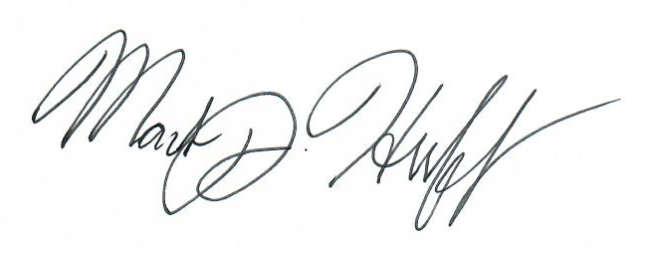

Mark J. Huff, PhD

Assistant Professor, Psychology

The University of Southern Mississippi

601.266.5411

mark.huff@usm.edu

I will be presenting my research at the 60th meeting of the Psychonomic Society, which will be held November 14th through the 17th in Montreal, Canada. The Psychonomic Society is one of the largest international societies of cognitive psychologists, with approximately 5000 members across the world, including some of the most distinguished researchers in the field. The primary goal of the society is to encourage the growth of cognitive psychology as a science through the publication of scholarly journals and annual meetings. These meetings focus on new and emerging areas of study, the use of novel research techniques, and have an emphasis on fostering collaboration amongst and discussion amongst cognitive psychologists.

Participating in this conference is important to my professional development as an academic for two reasons. First, this conference provides me with the opportunity to present my research on an international scale. This is valuable experience, as it allows me to receive feedback on my work from experts in the field, share my work to a diverse audience, and gives me exposure to new and emerging trends within the field of cognitive science. Second, this conference provides me with an excellent opportunity to make connections with other researchers in the field, as I will have the opportunity to network with experts, and connect with other graduate students conducting related research, which opens up the possibility of collaboration on future products.

**Submission Confirmation:**

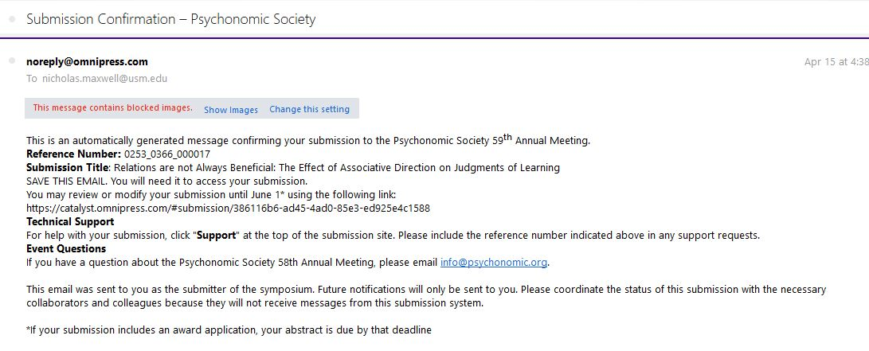

**Submitted Abstract:**

Title: Relations are not Always Beneficial: The Effect of Associative Direction on Judgments of Learning

Authors: Nicholas P. Maxwell & Mark J. Huff

The associative direction of cue-target pairs has been shown affect the accuracy of memory predictions through judgements of learning (JOLs). Forward associative pairs (e.g., credit-card) are generally well calibrated (i.e., similar JOL estimates and later recall accuracy), however JOL ratings often exceed later recall accuracy for backward pairs (e.g., card-credit). The present study evaluates this pattern by examining the correspondence between JOLs and recall accuracy on symmetrical (e.g., salt-pepper), forward, backward, and unrelated pairs when study was either self-paced (Experiment 1) or when a 5-second deadline was given to study and provide a JOL (Experiment 2). Across experiments, JOLs accurately estimated recall accuracy for forward pairs, but overestimated recall for symmetrical, backward, and unrelated pairs. Novel calibration plots depicting JOL ratings against their corresponding recall accuracy indicated JOL overestimations occurred across recall accuracy levels for unrelated pairs, but JOLs only overestimated recall accuracy for symmetrical, forward, and backward pairs when recall accuracy was relatively high (> 60%).

**Estimated Budget:**

I am expecting a round trip flight to Montreal to cost at least $400.

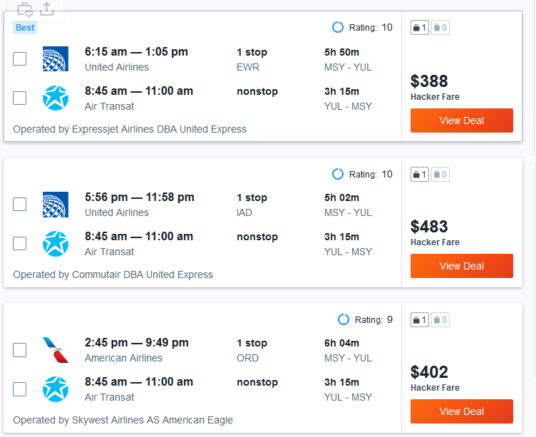

The conference sponsored hotel is not yet available, but a search of nearby listings shows that I should expect to spend at least $100 a night on hotel accommodations. Since I will be staying for four nights, I should expect to spend at least $400.

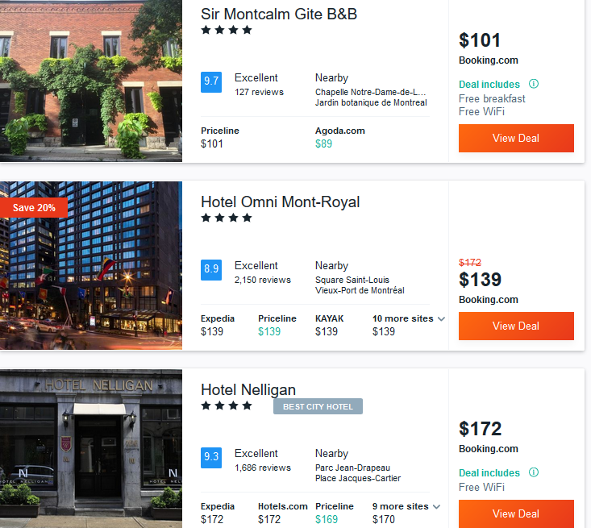

Finally, The U.S. Department of State meal per diam for Montreal is $110 per day. (<https://aoprals.state.gov/web920/per_diem_action.asp?MenuHide=1&CountryCode=1079>). For four days, that would be approximately $400.

Thus, I am anticipating that the cost of this trip will be approximately $1,200.